Welcome: Quel Temps Fait-Il?
Description: Quel temps fait-il? This quest will allow the student to discover the weather in France and other French-speaking countries. The student will appreciate the various weather conditions as a supplement to this lesson.
Grade Level: 9-12
Curriculum: Foreign Language
You are a Meteorologist researching the weather for various cities in the France.
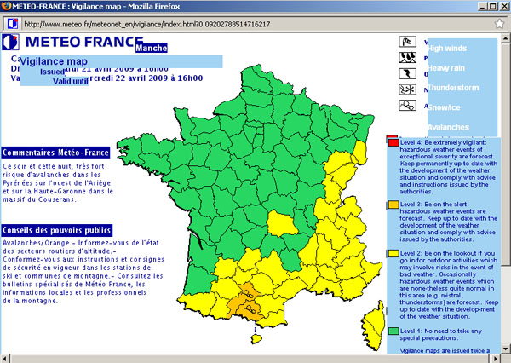
It is up to you to research the weather and alert the people of any weather disturbances in the area in the next five days.
Create a PowerPoint slide presentation on a French city and give a five day forecast for your city. You will need to prepare the following information:
- a title page with your name, the title Quel Temps Fait-Il?, French II, and date
- the city of your choice shown on a map
- the vocabulary relating to weather from chapter 11 and handouts
- a five day forecast starting Friday, October 3-Tuesday, October 7
- the weather for each season (le printemps, l'ete, l'hiver, l'automne) in your city
- any other interesting facts about weather in your city...how much does it rain, how much snow does it get each winter, when was the hottest day ever, what was the temp., when was the coldest day ever, and what was the temp, etc.
You will be researching this project as follows:
STEP 1
Gather information from the web and other sources to determine the weather for the country that you have chosen. Be sure to gather pictures that are associated with the weather forecast. Some sites to research are as follows:
http://www.wunderground.com/global/FR.html
http://www.worldweather.org/
http://www.weather.com/
http://www.noaa.gov/
http://www.accuweather.com/
http://www.meteo.fr/meteonet_en/index.htm
STEP 2
Create a PowerPoint presentation with your five-day forecast for the country that you have chosen. In your presentation include the day of the week, the weather forecast, and other information that you find to be useful.
STEP 3
Edit and rehearse your presentation making sure all proper vocabulary is indicated. Be sure to include pictures and/or maps to illustrate your understanding of Frernch weather.

temps_for_quest_3.ppt
Season vocabulary

french_1_weather_vocabulary_worksheet.doc
Weather vocabulary worksheet

Evaluation Rubric
 | Beginning 1 | Developing 2 | Very Good 3 | Exemplary 4 | Score
Content and Accuracy | Content is typically confusing or contains more than one error. | The content is generally accurate, but one piece of information is clearly flawed or inaccurate. | Most of the content is accurate but there is one piece of information that might be inaccurate. | All content throughout the presentation is accurate. There are no errors. | %25
Spelling and Grammar - Use of Proper Vocabulary | Presentation has many spelling errors and very limited vocabulary. | Presentation has good vocabulary but two or more grammatical errors. | Presentation has very good vocabulary but 1-2 misspellings. | Presentation has used all necessary vocabulary with no grammatical errors. | %25
Sequencing of Information | There is no clear plan for the organization of information. | Some information is logically sequenced. An occasional card or item of information seems out of place. | Most information is organized in a clear, logical way. One card or item of information seems out of place. | Information is organized in a clear, logical way. It is easy to anticipate the type of material that might be on the next card. | %25
Cooperation | Group often is not effective in delegating tasks and/or sharing responsibility. | Group delegates tasks and shares responsibility effectively some of the time. | Group delegates tasks and shares responsibility effectively most of the time. | Group delegates tasks and shares responsibility effectively all of the time. | %25
Total Score: %100

